Design Patterns for Pattern Illustrating
Konomi munakata, Faculty of Environment and Information Studies, Keio University
Rio Nitta, Faculty of Policy Management, Keio University
Kotomi nozaki, Faculty of Policy Management, Keio University
CHIAKI SANO, Faculty of Environment and Information Studies, Keio University
TAKASHI IBA, Faculty of Policy Management, Keio University
This paper presents fifteen design patterns for Pattern Illustrating, which support people to come up with the fundamental design structure of good pattern illustrations. Pattern Illustrating is a process of visualizing the essence of each pattern, conducted after Pattern Mining and Pattern Writing in the process of pattern language creation. It has been recognized as an important process, not only for making patterns more intuitively understandable for readers, but also for pattern writers to recapture the essence of each pattern and improve the quality of language as a whole. In this paper, we also explain how these patterns were found out with a KJ clustering approach, using 333 illustrations of different patterns created by Iba Lab for eleven themes on human actions. We hope that this attempt makes it easier for people to conduct pattern illustrating in the practice of creating patterns.
Additional Key Words and Phrases: design patterns, pattern illustrating, KJ method, pattern language creation
ACM Reference Format:
Munakata, K., Nitta, R., Nozaki, K., Sano, C and Iba, T. 2018. Design Patterns for Pattern Illustrating. HILLSIDE Proc. of Conf. on Pattern Lang. of Prog. 25 (October 2018), 13 pages.

INTRODUCTION
Visualizing ideas often helps people understand something new and abstract. In the study of Cognitive Theory of Multimedia Learning, it has been proved that people “can learn more deeply from well-designed multimedia messages consisting of words and pictures than from more traditional modes of communication involving words alone” (Mayer 2002).
In the field of pattern language, photographs, diagrams and sketches have been effectively utilized to support readers understand the ideas well. Such visual aids can also encourage people recall patterns and practice them in their daily lives. We, Iba Lab, have also created more than 1,600 patterns of human actions with illustrations, since the publication of Learning Patterns in 2008 (Iba et al., 2009; Iba and Iba Lab 2014) (Fig.1). In our pattern languages, the essential message of each pattern is visually expressed with a special character named Manabu-kun, through his actions and facial expressions (Miyazaki 2015) (Fig.2).
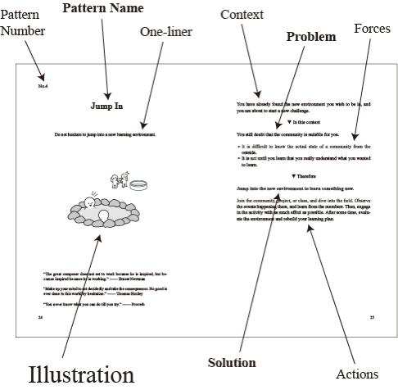
Fig. 1. Pattern format designed by Iba Lab
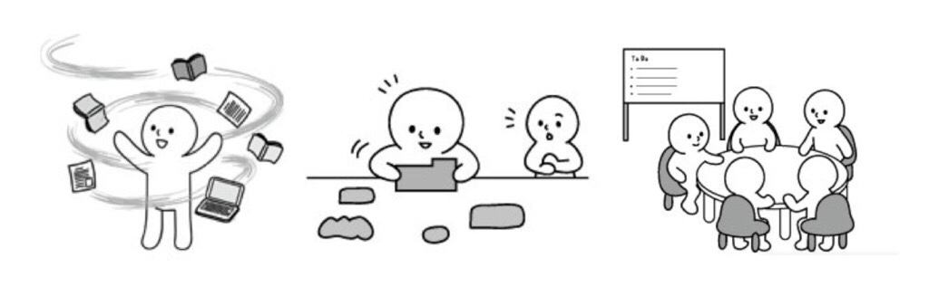
Fig. 2. Examples of illustrations (Manabu-kun) in Learning Patterns (2008): Tornado of Learning (No.10), Prototyping (No,17) and Community of Learning (No.28)
However, we found out that not everyone can draw good illustrations which provide readers with a better understanding of patterns and bring them new perspectives, capturing the essence of each pattern. Therefore, we created Pattern Illustrating Patterns (2015), to support people who want to draw good pattern illustrations (Miyazaki 2015). They were created based on the practices of pattern illustrating conducted by Iba Lab members who have experienced pattern illustrating for several pattern languages we had created so far.
Although this set of patterns work well in terms of sharing basic ideas of how to draw pattern illustrations, it does not explain enough about the “structure of design” itself. In our practice, however, we find it necessary to create design patterns which are more practical in terms of coming up with the initial sketch of the fundamental structure of each pattern illustration. Therefore, 15 design patterns for pattern illustrating were created based on 333 illustrations of patterns created by Iba Lab for 11 different themes. In this paper, we introduce these patterns and explain its creating process.

Pattern language and illustration
The attempt to add a visual expression to the description of pattern is not something new and special. Christopher Alexander, the inventor of Pattern Language, has stated “if you can’t draw a diagram, it isn’t a pattern” in his book of “The Timeless Way of Building (1979)” (Alexander). In order to share the patterns which are very complicated to be precisely described with words, he stressed the importance of “expressing and visualizing a pattern as a kind of fluid image, a morphological feeling, a swirling intuition about form” (Alexander 1979). In “A Pattern Language (1977)”, therefore, he used a lot of visual images such as photos and sketches in the description of each pattern.
The importance of visual aids has been recognized not only in the pattern languages for structural design such as architecture and software, but also in the field of pattern languages for human actions (what we call Pattern Language 3.0). Illustrations put abstract ideas and concepts, which are often very difficult to be described in words, into a visible form, and help readers understand and implement the practices written in patterns (Miyazaki 2015).
Moreover, the process of pattern illustrating effectively works for pattern writers as well, when they want to improve their own patterns. “This process presupposes the descriptions of patterns, but it also asks the improvement and modification of themselves. In this sense, this process is very unstable. Because of this instability, the process of pattern illustrating works very well not only for making the patterns more understandable for readers, but also for improving the pattern themselves” (Harasawa 2015). What it means here is that drawing pattern illustrations requires pattern creators to read the patterns over again, recapture the essence of patterns and compress it in a visible expression. If they find difficulty in this process, it often means that the message of the pattern expressed in words is still ambiguous and not “strong” enough as a pattern, and it needs to be reconsidered and improved. In other words, a good pattern should be easily visualized in a single picture.
In fact, in our practice of creating a pattern language for nursery, pattern illustrating played a significant role (Fig. 3). When each of the members independently drew an illustration for a single pattern and showed it to other members, it became obvious how clear or ambiguous its description was. For example, Fig.4 shows the illustrations drawn by four individual members for a single pattern. When we showed them to each other, we recognized that they are relatively similar, and could conclude that the message we could get from the pattern was clear and strong enough.
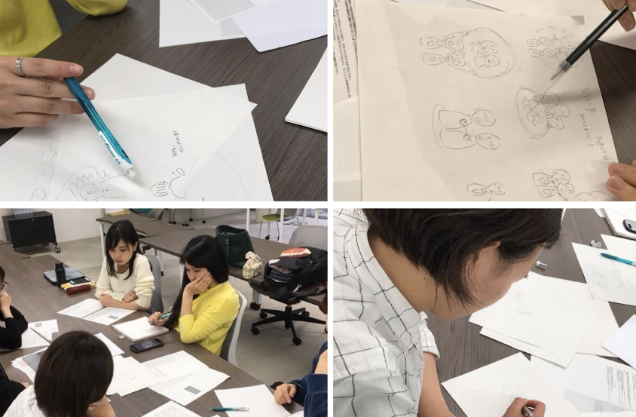

Fig. 3. Pattern Illustrating for a pattern language for nursery
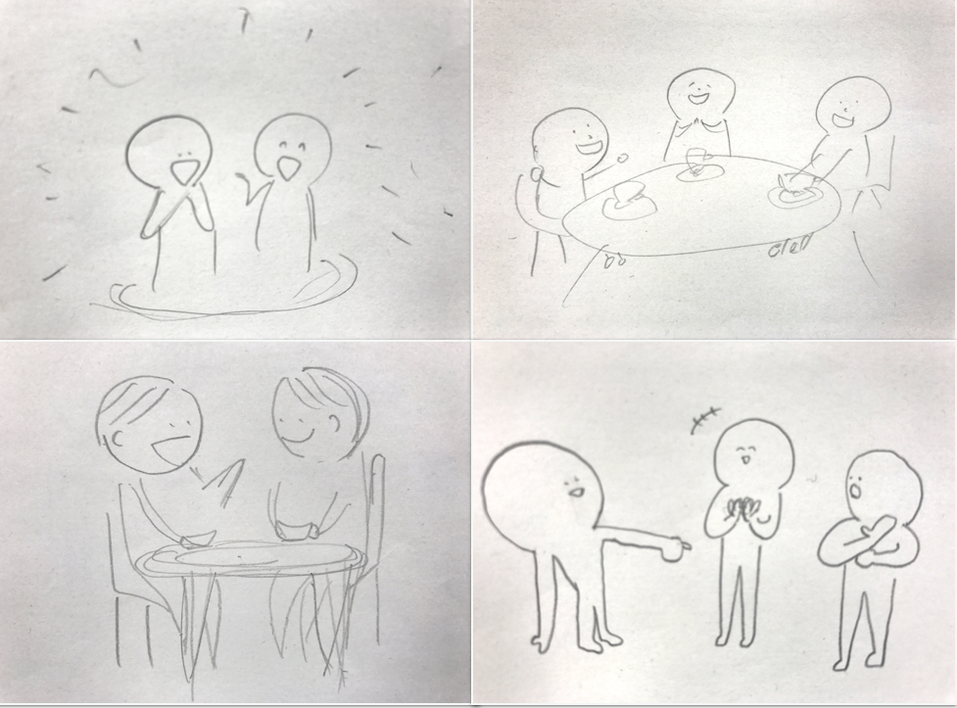
Fig. 4. Pattern Illustrations for one pattern
On the other hand, Fig.5 shows when each of us drew totally different illustrations for another single pattern. In such case, we had to discuss and explore the meaning of patterns all over again, before anything to do with pattern illustrating. In this way, we could significantly improve the descriptions of patterns and some pattern names were updated as a result.
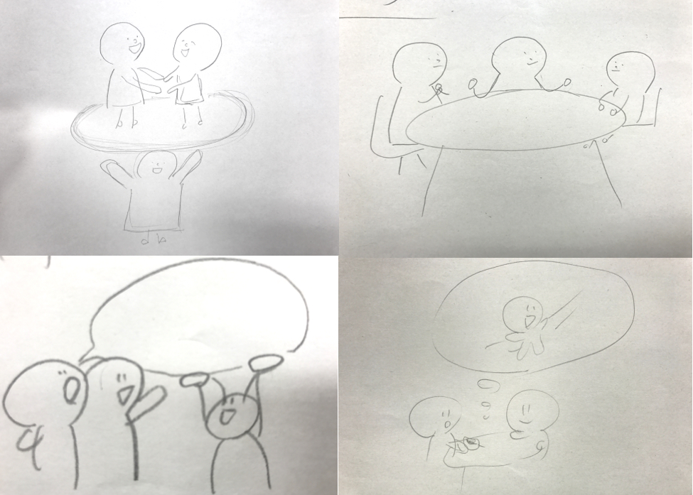
Fig. 5. Pattern Illustrations for another pattern
Therefore, we put significant emphasis on the process of Pattern Illustrating as much as Pattern Mining and Pattern Writing. In our Lab, however, pattern illustrating has been conducted by only a few members “who can draw pictures well”. In order to open this creative and meaningful process to more people, we have been studying the pattern illustration since 2014. Pattern Illustrating Patterns (2015) introduced in the PLoP Conference in 2015 was our first attempt.

pattern illustrating patterns (2015)
Pattern Illustrating Patterns (2015) were created to support people to draw good illustrations which express the essence of each pattern and help readers understand the patterns better (Iba, T. and Iba Lab 2015). These 28 patterns were created based on the experiences of pattern illustrators from Iba Lab, and categorized into five groups. Here is the overview of the 28 patterns.
The Core Patterns consist of the following patterns which describe the basic idea of pattern illustrating. Essential Message (No.1): Consider pattern illustration as having the same value as the pattern description; try drawing an illustration that contains the pattern’s essence. Moving Characters (No.2): Draw a character that embodies the pattern’s essential message. Symbolic Representation (No.3): Draw the scene that solves the problem within the context.
The next three group consists of 18 patterns for drawing elements, determining the scene and space, and finishing touches to raise the quality. Here are the examples. Center Words Hunting (No.4): Identify essential strong words or phrases to grasp the pattern’s essence. Layout of Space (No.10): Draw the illustration as if you are coordinating the 3D space. Consistent Story (No.17): Imagine a story about your pattern language’s topic and use consistent motifs to draw different scenes from the same story.
The last group of 6 Patterns describe the important mindset as a pattern illustrator. External Inspiration (No.23): Look at outside sources for ideas about what to draw. Third Person View (No.24): Show the illustration to someone unrelated to the pattern to get fresh ideas. Improving by Drawing (No.27): Through the process of creating a pattern illustration, improve the verbal expressions of the pattern itself.
Although these 28 patterns are very useful in terms of sharing the way of thinking necessary for pattern illustrating, they have not mentioned the “structure” or “form” of the design in detail. In order to open the process of pattern illustrating, however, we find it necessary to find out more patterns which are technically more practical to visualize the patterns on a piece of paper. We therefore decided to create Design Patterns of pattern illustrations.

Design patterns for pattern ilustrating
We have created design patterns for pattern illustrating, based on the illustrations drawn for 333 patterns in the following eleven themes: Learning Patterns (2009), Presentation Patterns (2012), Collaboration Patterns (2013), A Pattern Language for Surviving Earthquakes (2013), Words for a Journey: A Pattern Language for Living Well with Dementia (2014), Cooking Patterns (2016), Project Design Patterns (2016), A Pattern Language “Ways of Everyday World Making” (2016), Active Learning Patterns for Teachers (2017), Life Transition Patterns: A Pattern Language for Shaping Your Future (2017) and Open Dialogue Patterns (2017). These pattern illustrations were created by multiple people as shown on the following table.

Table 1 List of patterns used for creating Design Patterns for Pattern Illustrating
Title of Pattern Language (year of publication) | Total number of patterns | Pattern Illustrators
Learning Patterns (2009) | 40 | Toko Miyake & Takashi Iba
Presentation Patterns (2012) | 34 | Kaori Harasawa, Rinko Arao & Takashi Iba
Collaboration Patterns (2013) | 34 | Kaori Harasawa, Rinko Arao, Ayano Tamefusa, You Ikeda & Takashi Iba
A Pattern Language for Surviving Earthquakes (2013) | 20 | Kaori Harasawa
Words for a Journey: A Pattern Language for Living Well with Dementia (2014) | 40 | Arisa Kamada, Tasuku Matsumura & Takashi Iba
Cooking Patterns (2016) | 27 | Yuma Akado, Rika Sakuraba & Takashi Iba
Project Design Patterns (2016) | 32 | Kaori Harasawa
A Pattern Language “Ways of Everyday World Making” (2016) | 34 | Kaho Takahashi & Takashi Iba
Active Learning Patterns for Teachers (2017) | 45 | Takashi Iba & Yuma Akado
Life Transition Patterns: A Pattern Language for Shaping Your Future (2017) | 27 | Takashi Iba
Open Dialogue Patterns (2017) | 30 | Takashi Iba

Here are the 15 design patterns for pattern illustrating we have created.

No.1 Direction to the Future
The pattern implies the future, or it encourages readers to become more conscious of something in the future. In this context, it is difficult to draw the current situation, recommended action and consequential future all together on the same plane, making sure that they can be clearly distinguished. Therefore, draw the future-related event in upper-right corner, and express the change as time flows from bottom left to top right.
Fig. 6. Direction to the Future
No.2 Substantialized Voice
The pattern puts significant emphasis on the emotion, words or something invisible and conceptual. In this context, because they have no visible form, it is difficult to illustrate them and how they relate to the recommended action. Therefore, represent them in the form of bubbles, and let the character touch or transform them, in order to illustrate the specific action described in the pattern.
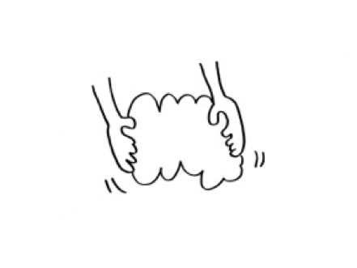
Fig.7. Substantialized Voice
No.3 Representing Three
You want to show the variety of something or different options. In this context, you may try to draw things as much as possible, but it makes the illustration chaotic, and thus the important message of pattern is likely to be blurred. Therefore, draw only three of them as representative examples.
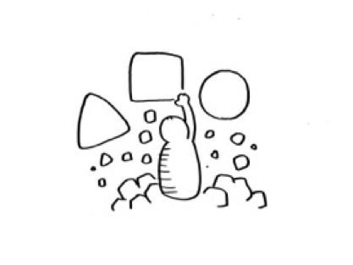
Fig. 8. Representing Three
No.4 Standing on the Same Side
The pattern implies that there are multiple people who are in the same situation, sharing something together and working collaboratively. In this context, if you just draw multiple people, such relationship cannot be well represented. Therefore, draw a few people from the back side and emphasize that they are facing in the same direction.
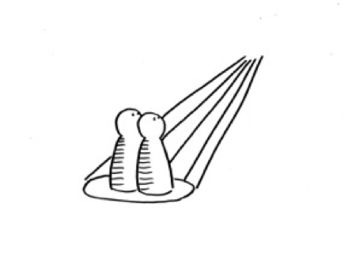
Fig.9. Standing on the Same Side
No.5 After Selection
The pattern asks readers to prioritize something or choose something from among many. In this context, if there is only the selected one drawn, readers may not be able to see the importance of the action behind it. Therefore, draw the things unselected as well to emphasize that it is the one selected.
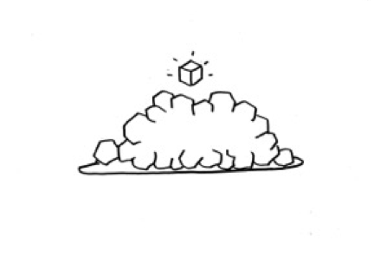
Fig.10. After Selection
No.6 Sharing in a Circle
The pattern emphasizes the significance of collaboratively working with others. In this context, it is express the sense of unity on the illustration, as it is invisible. Therefore, let them make a circle and face each other. In this way, readers can imagine that people share their time, space and opinions with each other in a collaborative way.
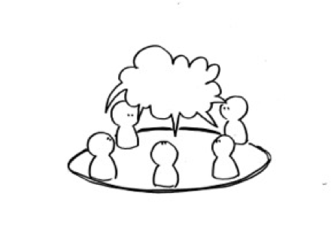
Fig. 11. Sharing in a Circle
No.7 Emotional Arms
You want to show the important feeling which is coming along when taking the action written in the pattern. In this context, although people often try to express such strong emotion only through the character’s facial expression, it is likely to be misunderstood. Therefore, you should not only express the important feeling through the character’s facial expression, but also make their arms characterized as well. For example, you can let the character make a fist and raise the arm above the chest, to show the importance of taking action passionately.
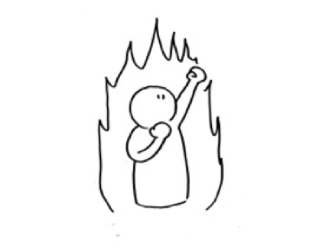
Fig. 12. Emotional Arms
No.8 Rapid Change
The pattern encourages readers to make a big change within a relatively short period of time. In this context, drawing the changing process or the changed situation when the pattern is implemented, would not be enough to tell readers the rapidity of growth. Therefore, draw the representative thing expanding from the bottom to the top, with the small starting point and the bigger goal.
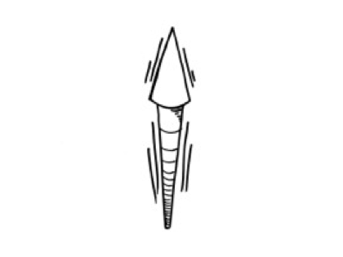
Fig. 13. Rapid Change
No.9 Mind-full Action
The pattern encourages readers to take action mindfully. In this context, it is difficult to visualize the inner state of the person. Therefore, draw the character with its eyes closed and the hand on the chest, to express his concentration.
Fig. 14. Mind-full Action
No.10 Extensive Network
You want to illustrate the relationships among people or things. In this context, if you just draw lines in between different elements to represent the network in one place, different levels of strength of the relationship cannot be well illustrated. Therefore, draw the network extensively to show the depth of the network from a specific point of view.
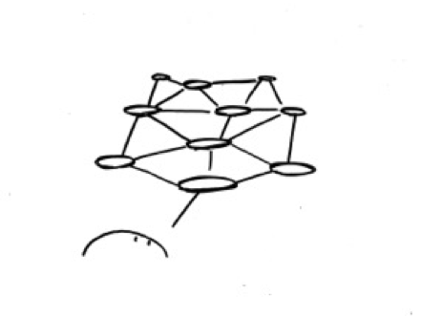
Fig. 15. Extensive Network

No.11 Expansive Spiral
The pattern encourages readers to take action expansively. In this context, if you draw only the finished state, it would not explain enough about the process in which something is expansively progressing. Therefore, draw a growing spiral which spreads gradually from the bottom to the top.
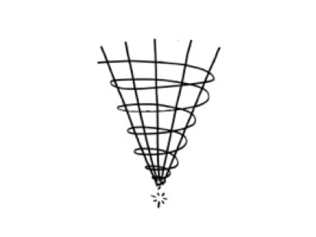
Fig. 16. Expansive Spiral
No.12 Active Leaning
The pattern emphasizes the importance of taking action positively and actively. In this context, if you just draw a person who is taking action, it would not tell enough about the positive attitude towards the practice within the pattern. Therefore, let the character a little bit lean forward.
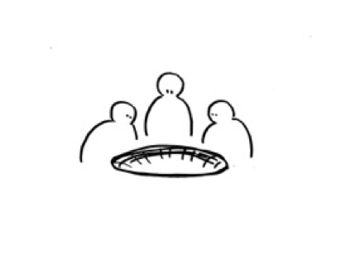
Fig. 17. Active Leaning
No.13 Challenging Darkness
The pattern offers a challenge. In this context, simply drawing the consequence of the pattern would not be enough to tell readers that they have to challenge difficulties. Therefore, paint the back in black and brighten the direction for pioneering.
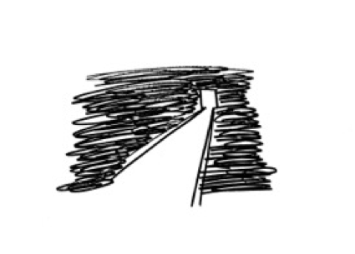
Fig. 18. Challenging Darkness
No.14 Accumulation of Actions
The pattern encourages readers to make a progress a little by little. In this context, simply drawing the consequence of the pattern would not be enough to tell readers the importance of its gradual progress. Therefore, draw the act of piling up small pieces of something such as blocks, to emphasize that the goal has to be achieved with small steps.
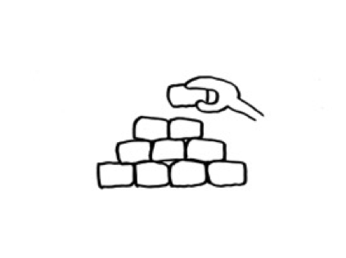
Fig. 19. Accumulation of Actions
No. 15 Repeated Practices
You want to recommend readers a repeated use of the pattern. In this context, simply drawing the consequence of pattern would just seem like suggesting a temporal implementation of the pattern. Therefore, draw the character sitting in front of a desk to emphasize that the pattern should be practiced repeatedly to achieve the goal.
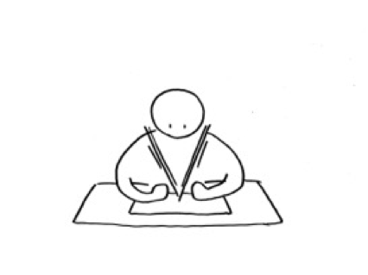
Fig. 20. Repeated Practices
These 15 Patterns makes it easy to draw the fundamental structure of a pattern illustration as a rough sketch. The sketch should then be elaborated and drawn nicely as a final version by people who have a good skill of drawing. In this way, every pattern language creators can join the process of pattern illustrating, regardless of how good they can actually draw the character, making it more collaborative.
Furthermore, this illustrating process is very consistent with the Christopher Alexander’s idea of creation, in the way that it asks people to elaborate the design further based on the initial rough sketch to create a completed one. In his own words, this process can be rearticulated as “differentiation (Alexander 1979)”, where the design object is seen as an individual whole, and all the details of the structure is developed later as a sequence. “It is not a process of addition, in which pre-formed parts are combined to create a whole, but the process in which every individual act of building differentiates the space. It is a process of unfolding, like the evolution of an embryo, in which the whole precedes its parts, and actually gives birth to them, by splitting” (Alexander 1979 p384). In “The Timeless Way of Building” and “The Nature of Order”, Alexander stressed that the differentiation of the whole is the very essence of designing. We also believe that pattern illustration can achieve the “Quality Without a Name” in this way.

How patterns were found
These design patterns for pattern illustrating were created, using the KJ method (Kawakita 1967). KJ Method was originally invented by Jiro Kawakita, a cultural anthropologist, to organize data collected from various cultures. We have used this method as a foundation of our pattern clustering method (Iba, et al. 2017).
In this project, we carried out the KJ Clustering with pattern cards where the description and illustration of each pattern is printed on. First of all, all the pattern cards were placed on a piece of craft paper randomly (Starting from Chaos) (Fig. 21). We then compared pairs of cards, looked at their illustrations and brought together if they have similar ones (One-to-One Comparison) (Fig. 22). Here, it is important to keep in mind that feelings rather than rational thinking play a significant role in the KJ Clustering. Simply moving cards with existing classification standards such as “-ish” and “-related” is not expected. Rather, the idea is to grasp the essence of what is drawn on the illustrations. When the classification of the illustrations made sense to all of us, we circled each group of cards to clarify the “islands” which would become seeds of patterns (Discovering the Islands) (Fig. 23).
As a result of our KJ Clustering, 36 islands were found out (Fig. 24). Although most of them had unclear and uncertain “problem-force” and we were unable to write their CPS Summary (Context, Problem and Solution), we could find 15 of them and created patterns.
Although we have got only 15 patterns so far, it must not be difficult to find more design patterns for pattern illustrating. Because there are plenty of ways to cluster the pattern illustrations in the KJ Clustering, there is no drought that we can find more seeds of patterns using the same cards. We could also use different pattern illustrations created by other pattern illustrators in the pattern language community, to elaborate the patterns further.

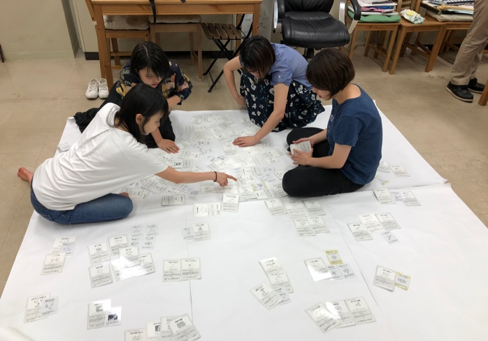
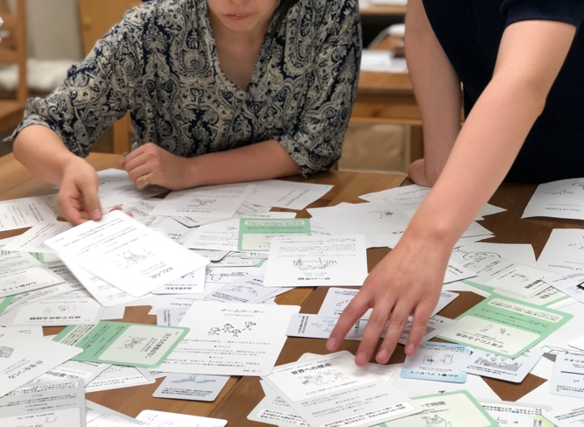

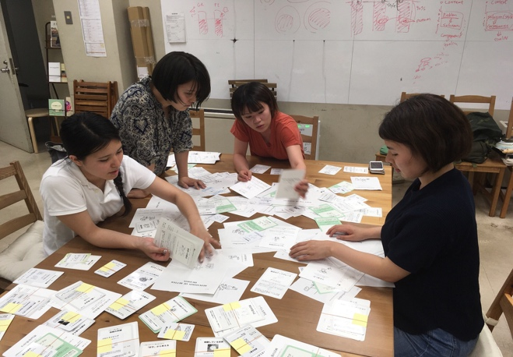
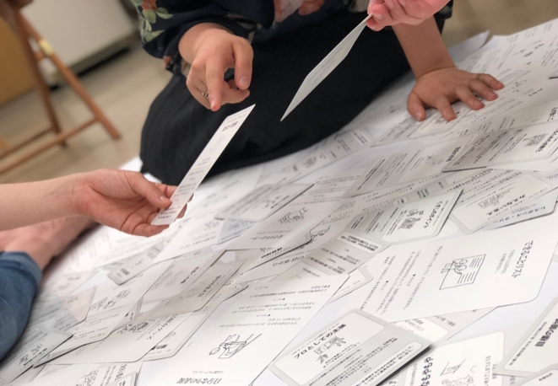
Fig. 21. Starting from Chaos

Fig. 22. One-to-One Comparison
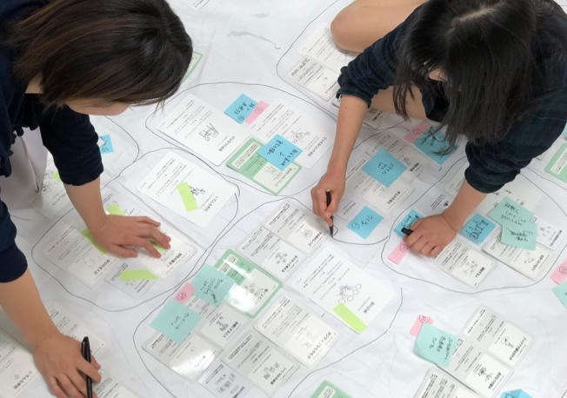
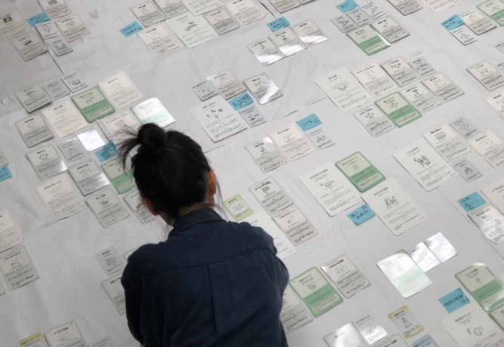

Fig. 23. Discovering the Islands
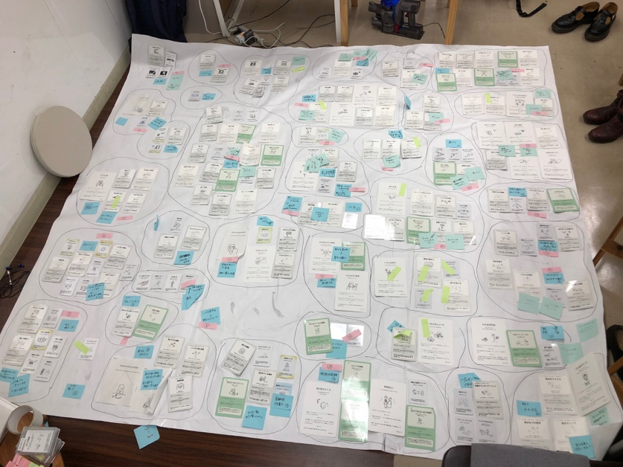

Fig. 24. Islands emerged after KJ Method

Conclusion
In this paper, we introduced 15 design patterns for pattern illustrating and emphasized the importance of pattern illustrating in the process of creating a pattern language, beyond the visual aid for readers. We are now planning to ask other people in the pattern language community to use them and see how it works. We hope that this attempt encourages pattern creators to practice the pattern illustrating and see it as an important process to improve the quality of the entire language.

REFERENCES
Akado Y, Shibata S, Yoshikawa A, Sano A and Iba T. 2016. Cooking Patterns: A Pattern Language for Everyday Cooking. 5th Asian Conference on Pattern Languages of Programs (AsianPLoP2016).
Alexander C, Ishikawa S, Silverstein M, Jacobson M, Fiksdahl-King I and Angel S. 1977. A Pattern Language: Towns, Buildings, Construction. Oxford University Press.
Alexander C. 1979. The Timeless Way of Building. Oxford University Press.
Alexander C. 2002. The Nature of Order: An Essay of the Art of Building and the Nature of the Universe, Book 1: The Phenomenon of Life, Routledge.
Furukawazono T, Seshimo S, Muramatsu D and Iba T. 2013. Designing a Pattern Language for a Surviving Earthquakes. 4th International Conference on Collaborative Innovation Networks (COINs2013).
Harasawa K, Miyazaki N, Sakuraba R and Iba T. 2014. The Nature of Pattern Illustrating: the Theory and the Process of Pattern Illustrating. ACM 3rd Asian Conference on Pattern Languages of Programs (AsianPLoP2014).
Iba T, Miyake T, Naruse M and Yotsumoto N. 2009. Learning Patterns: A Pattern Language for Active Learners. 16th Conference on Pattern Languages of Programs (PLoP2009).
Iba T, Matsumoto A and Harasawa K. 2012. Presentation Patterns; A Pattern Language for Creative Presentations. 17th European Conference on Pattern Languages of Programs (EuroPLoP2012).
Iba T and Isaku T. 2013. Collaboration Patterns: A Pattern Language for Creative Collaborations. 18th Conference on Pattern Language of Programs (EuroPLoP2013).
Iba T and Iba Laboratory. 2015. Pattern Illustrating Patterns: A Pattern Language for Pattern Illustrating. Creative Shift.
Iba T, Okada M, Iba Laboratory and Dementia Friendly Japan Initiative (DFJI). 2015. Words for a Journey: The Art of Being with Dementia. Creative Shift.
Iba T and Utsunomiya Y. 2017. Active Learning Patterns for Teachers. PURPLSOC Conference 2017.
Iba T, Mori H and Yoshikawa A. 2017. A Pattern Language for Designing Innovation Projects: Project Design patterns. International Journal of Entrepreneurship and Small Business.
Iba T, Yoshikawa A and Munakata K. 2017. Philosophy and Methodology of Clustering in Pattern Mining: Japanese Anthropologist Jiro Kawakita’s KJ Method. 24th Conference on Pattern Languages of Programs (PLoP2017).
Kawakita J. 1967. Hassouho: Sozosei Kaihatsunotameni [Abduction Method: For Creativity Development], in Japanese. Chuokoronsha.
Kubota T, Harashima Y, Mori H, Ishida T, Harasawa K and Iba T. 2016. Project Design Patterns: Patterns for Designing Architectural Projects. 5th Asian Conference on Pattern Languages of Programs (AsianPLoP2016).
Mayer E. R. 2002. The Promise of multimedia learning: using the same instructional design methods across different media. Eleseviewer B.V.
Miyazaki N, Sakuraba R, Harasawa K and Iba T. 2015. Pattern Illustrating Patterns: A Pattern Language for Pattern Illustrating. ACM. 22nd Conference on Pattern Languages of Programs (PLoP2015).
Nagai M and Iba T. 2017. Consideration of the Possibilities of Open Dialogue Patterns: through Creating and Performing the Learning Program of Dialogue. 7th International Conference on Collaborative Innovation Networks (COINs17).

This is our on-going study with The Center for Early Childhood Development, Education and Policy Research in Tokyo University.
The application of KJ Method in pattern language creation is explained in more detail in our previous paper, “Philosophy and Methodology of Clustering in Pattern Mining: Japanese Anthropologist Jiro Kawakita’s KJ Method (Iba etal. 2017)”, presented in the 24th Conference on Pattern Languages of Programs (PLoP2017).

